



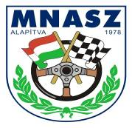

Total Rallycross Central-Europen Zone and National Champion Round
FIA CEZ RALLYCROSS ZONE CHAMPIONSHIP ROUND II.
MNASZ HUNGARIAN NATIONAL OPEN RALLYCROSS CHAMPIONSHIP, ROUND II.

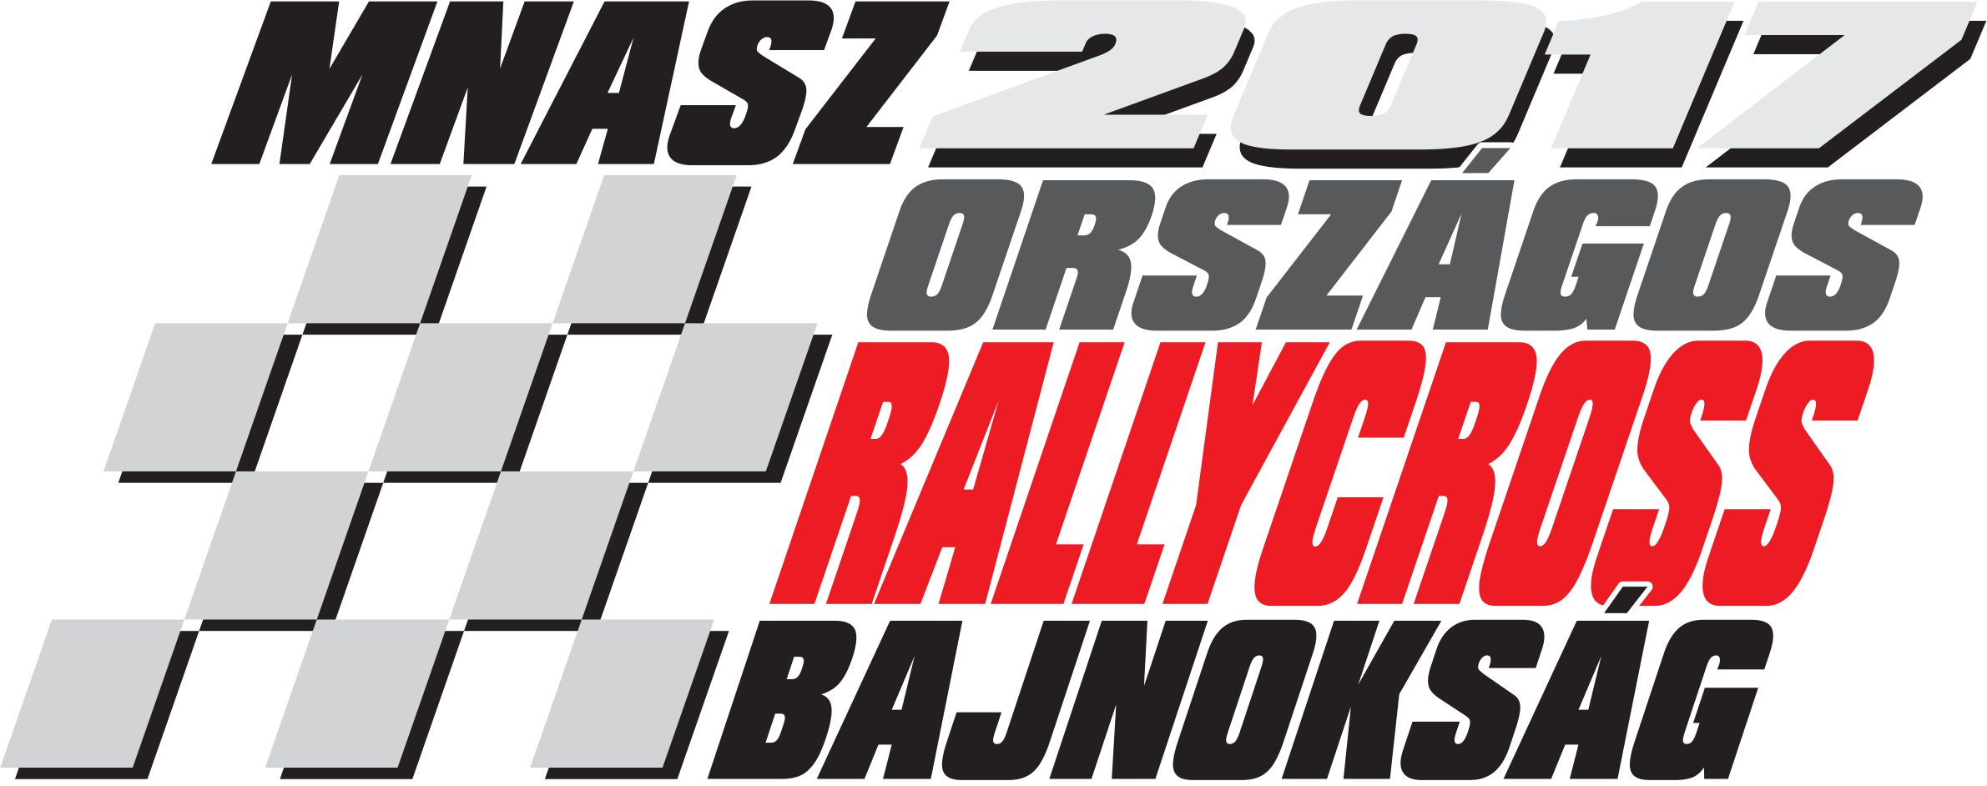
Venue: Máriapócs RabócsiRing
Date: 07-08. October 2017.
(Saturday, Sunday)

ENTRY FORM
(fields in bold brackets will be filled in by the organizer) (we kindly ask you to fill in the sheet in capitals)

Start No. |  | Division |  | Category/Class
 | Entrant (Club) |  | Driver
Name

Address

Telephone

License No.

Representative of the entrant
 |  | Data of the Race Car
Fabricate/Type |  | Chassis No. |  | FIA Homology Sheet No.
Displacement (ccm) |  | Division |  | Number of wheels driven

The undersigned hereby certify that they became acquainted with all requirements and regulations in the announcement and agree to meet all of them during the whole race. The data provided on the present sheet correspond to the facts and the entered car and all of its parts fulfill the requirements of the MNASZ Code and thus, the FIA International Code. Further, we are aware of the fact that during any rallycross event drug- and alcohol tests may be held.

Date | Signature of entrant (Club) | Signature of driver

